# **MIS 6308.002**

# **SYSTEM ANALYSIS AND PROJECT MANAGEMENT**

# **Group Project**



**Group No:** 2

**Group Members:** Musham Chaturvedi

Shubham Dave

Sruti Seshadri

Sriram Prasath Subbiah Pandiarajan

Tanya Bhardwaj

Contents

1. Project Presentation YouTube Link 3

2. Executive Summary 3

3. Problem Statement 4

4. Business Requirements 4

5. Objectives 5

6. Scope 5

7. Data Collection 6

8. Functional Specifications 7

9. Proposed Solution 7

10. Business Process Model Notation (BPMN) Diagrams 9

11. Context Diagram 11

12. Use Case Diagram 12

13. Use Case Descriptions 16

14. Data Dictionary 20

15. Class Diagram (without methods) 21

16. Sequence Diagram 22

17. Interface Design 23

18. Database Design 27

18.1 Entity Relationship Diagram 27

18.2 Design of tables 27

18.3 Database Constraints 28

19. Class Diagram (with methods) 30

20. Software Design 31

21. System Control Design 36

22. Weekly Project Timeline 37

23. Minutes of Meeting 38

24. References 53

# Project Presentation YouTube Link

The link to team presenting the project: [YouTube Link](https://youtu.be/QcA2RmCFVgk)

# Executive Summary

As regular users of the Comet Cruiser service, we analysed and proposed improvements to the existing system. We applied the basic understanding of System Analysis   
and Project Management to decipher the system in terms of System Development Life Cycle.

The current system provided all the data points related to Comet Cruisers to   
Transportation Department of UT Dallas as well as Public Information Office. However,   
it was not directly available to one of the most important stakeholders, commuters.   
Commuters (majorly consisting of students of UT Dallas) need to have the real-time data   
of the bus and its movements every day and yet it was almost impossible for them   
to know where is their bus in real-time or if there is enough space available for them or if they need to catch the next one and so on.

This project is intended to solve these problems present in the current system   
of Comet Cruisers for UT Dallas. The new system proposed uses IOT and Web 2.0   
to collect data from different sources like students, bus system, etc. After collecting   
the data, it processes it and disseminates quality information to bus commuters   
in real-time using which they can make informed decisions about their commute.   
Giving this information to commuters will make system more efficient in terms of serving   
its customers as well as it will also help in getting data for improving system   
by use of data analytics.

The project deliverables are:

1. Request for extra bus during peak hours.
2. Live tracking of the buses and average wait time of arrival for commuters.
3. Real-time bus & bike stand occupancy data for commuters

Internet of Things Deliverables:

1. Component health data for buses
2. Regulating temperature inside the bus automatically

These are the features which can be leveraged using crowd-sourced data and   
IOT to improve the efficacy of the system and help commuters as well as   
UTD Transport Department.

# Problem Statement

In the existing system, data regarding number of passengers and time of arrival   
at each stop for all trips of all different routes. However, this data was not   
being collected in real-time and due to it, it was difficult for the UTD   
Transportation Department to disseminate the information to commuters.   
Without knowledge about current location or current occupancy of the bus,   
the commuters had to wait at the bus stop.

Inadvertently, the commuters might be too late for the bus (if the bus was early   
than scheduled arrival time at a stop) and missed it or were too early and had to wait   
for it till the time it arrived (which could also be after the scheduled time   
in case of delays).

Also, during peak hours, the stops that come first in the route may fill up the bus   
and the commuters at stops later in the route would have to wait for another bus   
to come by. Even, the next bus could be filled up during peak hours, which would   
further waste time of commuters and all this just cause, the stop is positioned later   
in the scheduled route.

# Business Requirements

Due to the problems as mentioned above, this new system is being proposed which would help solve following business requirements:

* Tracking of bus in real-time to know if bus is delayed due to any traffic delays or breakdowns
* Providing the occupancy information of buses to commuters
* Collecting commuter data for different routes & timings and after collecting enough data over time, using it to increase the efficiency of buses by changes in route
* Managing occupancy in peak hours by use of extra bus on special routes
* Maintaining temperature inside the bus uniform without manual intervention to make the commute a better experience for commuters
* Collecting vehicle health data for different components on regular basis to track   
  and alert UTD Transportation Department for low health before the   
  bus breaks down

# Objectives

Objectives to be achieved by the new proposed system are as follows:

* Display average wait time of arrival for bus in real-time
* Display current position of the bus in real-time
* Display current occupancy of the bus in real-time
* Improve the availability of buses in timely manner during peak hours
* Improve the experience for users by maintaining uniform temperature inside the bus
* Improve the efficiency of Comet Cruiser system by managing occupancy and stops based on commuter data
* Reduce the number of breakdowns by alert system for low health for different components of the bus

# Scope

The scope of the new proposed system can be defined as follows:

* The proposed system would collect the data of commuters entered or exited at a stop and provide timely update for current occupancy & location of the bus.
* The proposed system would allow the driver to request for extra bus during peak timings (if the current bus is at its capacity)
* The proposed system would collect the data for commuters utilizing different routes of Comet Cruiser service and would provide better estimate of peak timings as well as modifications to routes required, if any.
* The proposed system would reduce the number of break downs by alerting the relevant authorities in cases of low health of bus components.

# Data Collection

A public information request was sent to UTD Transportation Department to collect   
the data about Comet Cruiser service. Apart from this, data was also collected   
by conducting interview of UTD Comet Cruiser drivers and commuting students.  
  
Based on both these activities, we found the following data points:

* How many drivers are available for Comet Cruisers?
  + 13 drivers
* What are the shifts for each of the drivers?
  + 2 shifts
    - 6:00 a.m. to 3:00 p.m.
    - 2:00 p.m. to 12:00 a.m.
* How many total buses are in circulation for Comet Cruisers?
  + 7 buses in circulation
* How many spare buses are available for Comet Cruisers?
  + 3 spare buses
* What are the number of trips for each bus per week?
  + On average 100 to 112 loops per bus weekly
* What is the average no. of passengers per route per week?
  + On average: 35,000 per week
* What is the fuel type for each bus?
  + Diesel fuel
* How much fuel is required by each bus per month?
  + This information is not available. Fuel consumption is kept by the vendor that runs the 883 services.
* How many breakdowns occurred for each of the Comet Cruiser routes?
  + 2 to 3 per week
* What is the distance between stops of each of the Comet Cruiser routes?
  + It varies for each stop.
* What is the average maximum capacity in terms of passengers for each bus
  + 60 to 65 passengers

# Functional Specifications

* Proposed functionality will provide the live tracking facility for UTD Comet Cruiser for all the routes and average waiting time using an app.
* Proposed functionality will provide real-time information of bus and bike stand occupancy using IOT.
* Proposed functionality will provide alerts to driver and UTD Transport Department for low health metric of different components of the bus.
* Proposed functionality will automatically adjust the temperature inside the bus by using collecting data using temperature sensors inside and outside the bus.
* Proposed functionality will allow the driver to request the transportation department to avail a spare bus during rush timings.

# Proposed Solution

Using IOT Sensors and App for Comet Cruiser commuters, following functionalities are proposed:

* **Live tracking & average wait time of bus**: Using GPS sensor for the buses, exact location of buses running on each route will be available. The location of each bus will be available to commuters via the app. The users will be given an option to select the start point for their journey and the route they want to travel on (since for hubs like UTD or McCallum community stop, multiple buses could be boarded). On selection of these options, the app will display the current location of the bus on a map interface using Google Maps API. Also, based on the starting point of the journey and current location of the bus, average wait time will be displayed by leveraging Google Maps API.
* **Current bus and bike stand occupancy**: Using sensors at entry/exit points of the bus, bus occupancy details will be captured. Also, a sensor will be kept for bike stand which will capture data of how many stands are in use for the bus. This information will be relayed to the backend servers by using IOT device after each stop. Using it and the total count of commuters on previous stop, the occupancy of the bus & bike stand will be calculated and displayed on the app for commuters by selecting respective route.
* **Bus health alerts**: Health of different components of the bus will be tracked by using sensors. These sensors will relay the health metric information to IOT device and will be processed in the backend servers. Backend servers will contain health metric thresholds for each component of different models of the buses. During processing, if health metric value for one of the component of the bus will go below the threshold, bus driver and UTD Transportation Department will be notified via alerts. This will help in bringing in the bus before it breaks down and sending extra bus to the location from where the bus (with low health) returned.
* **Automatic temperature balance**: Sensors will capture data of temperature within the bus and outside the bus and based on it, temperature of the bus will be balanced. This system could be overridden by the bus driver, in case of malfunction of the sensors, to make sure that the bus doesn’t heat up or cool down too much.

# Business Process Model Notation (BPMN) Diagrams

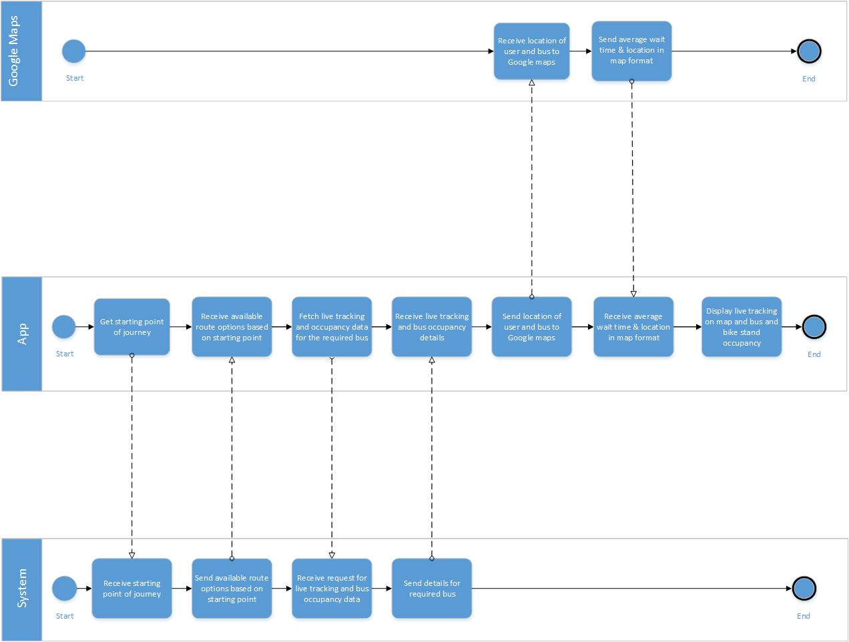BPMN diagram for displaying live tracking and bus occupancy details in app

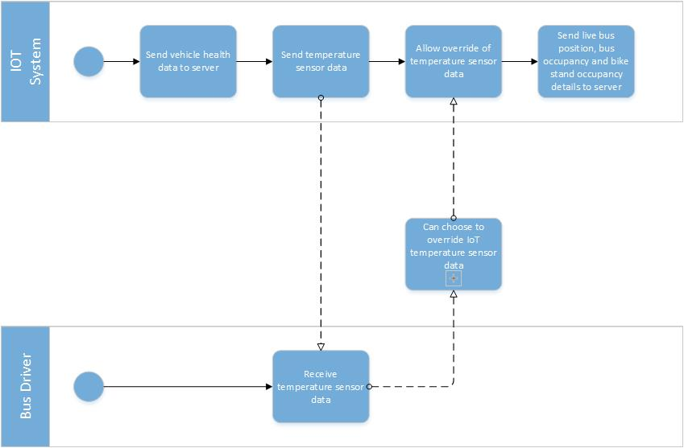

BPMN diagram for capturing and storing data from various sensors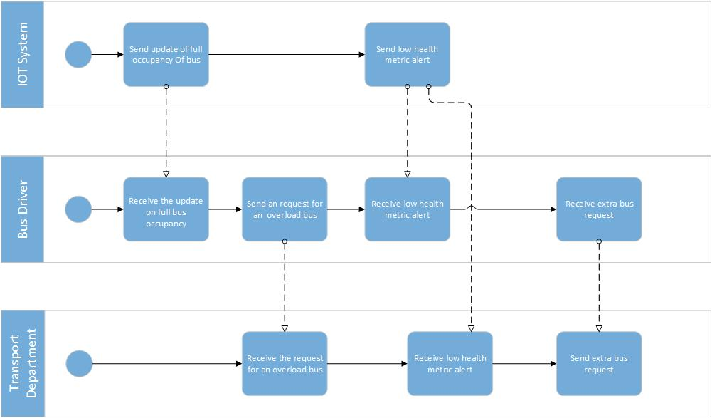

BPMN diagram for capturing full occupancy or low health alert

# Context Diagram

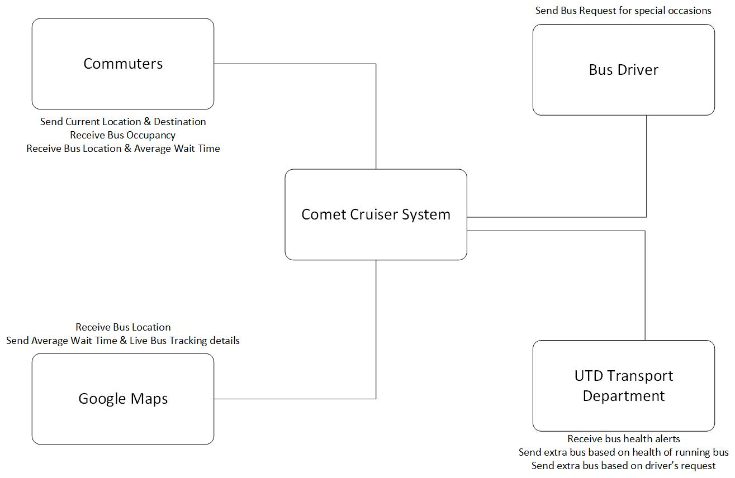

Context Diagram

# Use Case Diagram

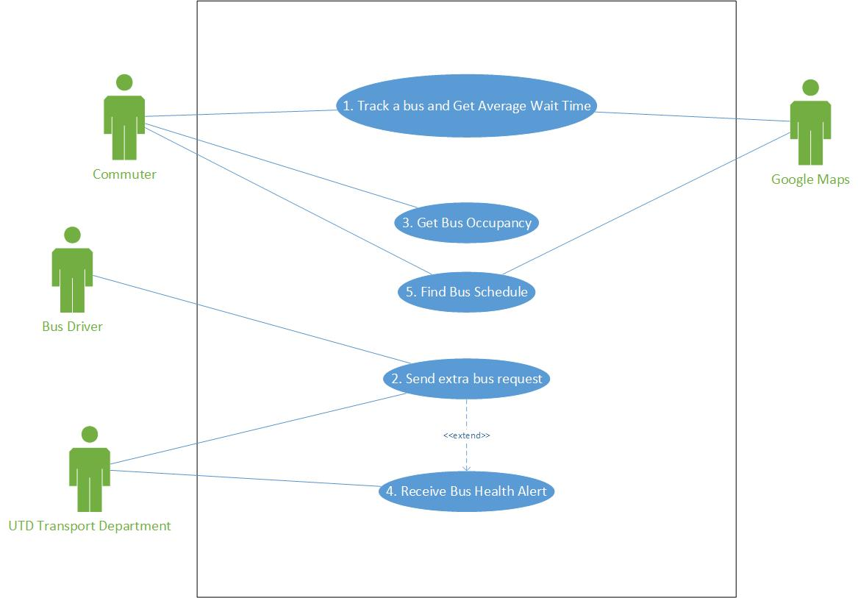

Use Case Diagram – Level 1

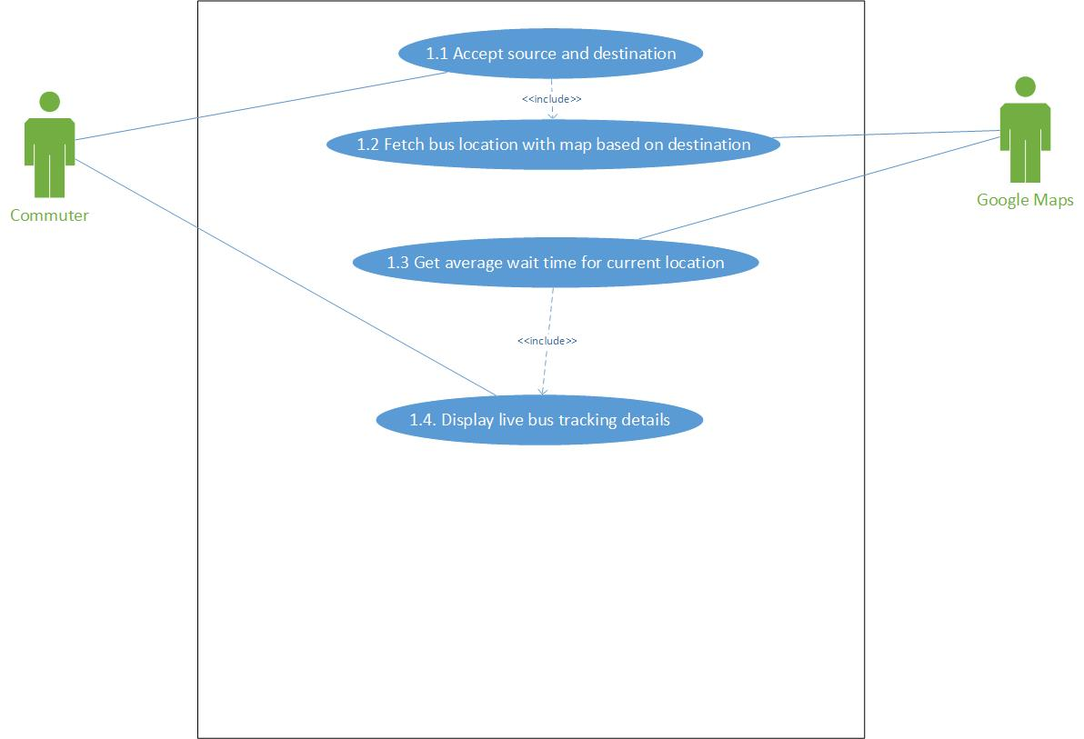Use Case Diagram for “Track Bus and Average Wait time” - Level 2

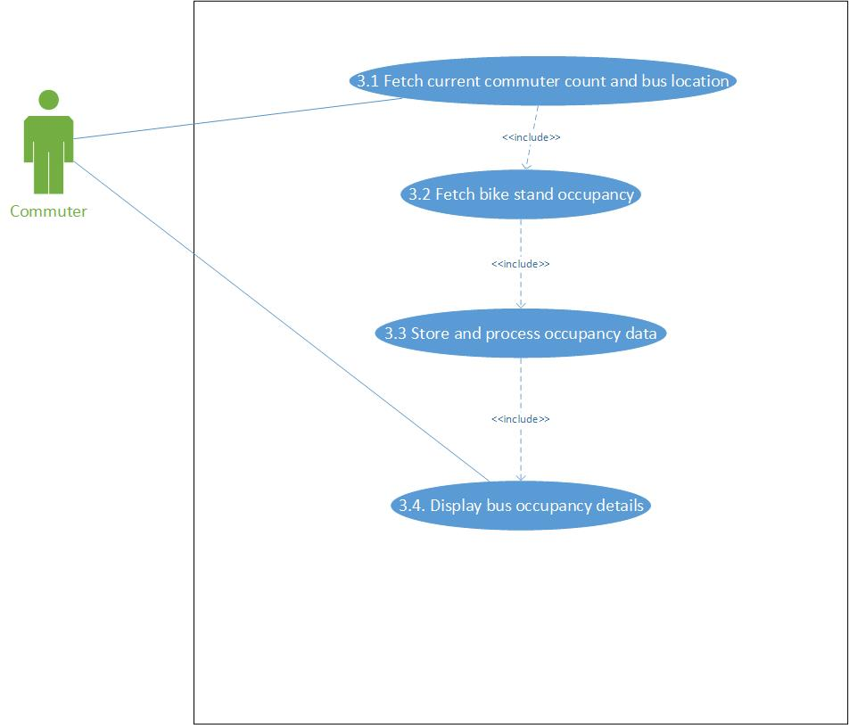

Use Case Diagram for “Get Bus Occupancy” - Level 2

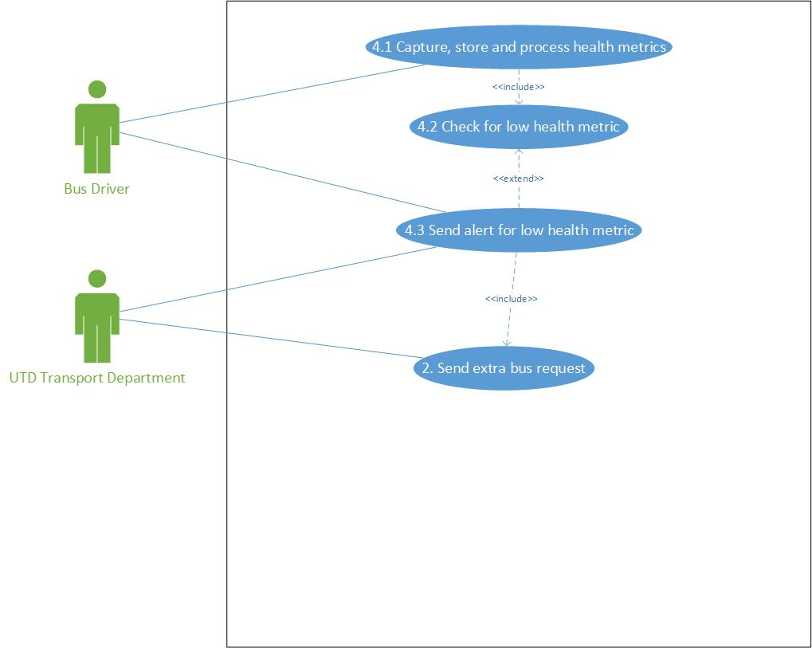

Use Case Diagram for “Receive Bus Health Alert” - Level 2

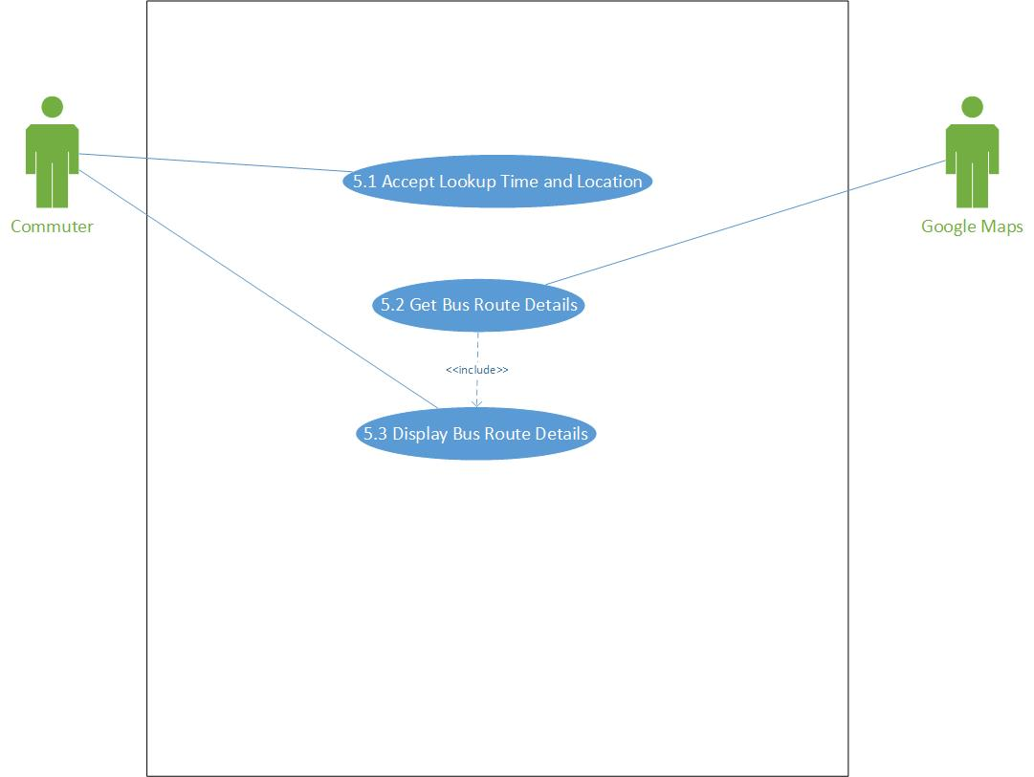

Use Case Diagram for “Find Bus Schedule” - Level 2

# Use Case Descriptions

|  |  |
| --- | --- |
| **Use Case Name** | Track Bus and Get Average Wait Time |
| **Use Case ID** | 1 |
| **Primary Actors** | Commuter and Google Maps |
| **Stakeholders & Interests** | Commuter – wants to know the current location of the bus and average wait time for bus to reach their location |
| **Brief Description** | This use case describes the process of live bus tracking and average wait time for commuter |
| **Trigger** | Commuter opens the app/website to know about bus’s current location and average wait time |
| **Trigger Type** | External Trigger |
| **Relationships** | |
| **Association** | Commuter and Google Maps |
| **Include** |  |
| **Extend** |  |
| **Generalization** |  |
| **Normal Flow of Events** | |
| 1. Get *source* and *destination* details from the commuter. 2. Display all *route* options for the selected *source* and *destination*. 3. Get *route* selected by the commuter. 4. Based on the *route* selected, fetch *current location* and *map* of bus running on that *route*. 5. Get average *wait time* for *source* from Google Maps based on *current location* of bus and *destination* as user’s selected *source*. 6. Display *bus tracking details* on app/website to the commuter. | |
| **Sub Flows** | |
|  | |
| **Alternate/Exception Flows** | |
|  | |

|  |  |
| --- | --- |
| **Use Case Name** | Get Bus Occupancy |
| **Use Case ID** | 3 |
| **Primary Actors** | Commuter |
| **Stakeholders & Interests** | Commuter – wants to know the amount of vacancy for seats as well as bike stand in the current bus for a route |
| **Brief Description** | This use case describes the process of getting bus seat and stand occupancy data |
| **Trigger** | Bus health becomes lower than safety threshold |
| **Trigger Type** | Internal Trigger |
| **Relationships** | |
| **Association** | Commuter |
| **Include** |  |
| **Extend** |  |
| **Generalization** |  |
| **Normal Flow of Events** | |
| 1. Get current *commuter count* based on commuters entered and exited on last stop and current *bus location*. 2. Get *bike stand occupancy*. 3. Store and process *occupancy data* in server. 4. Display bus and bike stand *occupancy data* in the app/website. | |
| **Sub Flows** | |
|  | |
| **Alternate/Exception Flows** | |
|  | |

|  |  |
| --- | --- |
| **Use Case Name** | Receive Bus Health Alert |
| **Use Case ID** | 4 |
| **Primary Actors** | Bus Driver and UTD Transport Department |
| **Stakeholders & Interests** | UTD Transport Department – wants to know if bus health is low and send extra bus before bus breaks down |
| **Brief Description** | This use case describes the process of getting alert if bus health is low |
| **Trigger** | Bus health becomes lower than safety threshold |
| **Trigger Type** | External Trigger |
| **Relationships** | |
| **Association** | Bus Driver and UTD Transport Department |
| **Include** |  |
| **Extend** |  |
| **Generalization** |  |
| **Normal Flow of Events** | |
| 1. Process and compare to check if any component’s health is below *safety threshold* from backend. 2. Send *alert* to UTD Transport Department and Bus Driver to bring the bus in for maintenance. 3. Send extra bus to the *location* where the called-off bus was present. | |
| **Sub Flows** | |
|  | |
| **Alternate/Exception Flows** | |
|  | |

|  |  |
| --- | --- |
| **Use Case Name** | Find Bus Schedule |
| **Use Case ID** | 5 |
| **Primary Actors** | Commuter and Google Maps |
| **Stakeholders & Interests** | User – wants to get schedule of buses during their required time interval |
| **Brief Description** | This use case describes the process of finding bus schedule between given time constraints |
| **Trigger** | User clicks on “Find Bus Schedule” in app/website |
| **Trigger Type** | External Trigger |
| **Relationships** | |
| **Association** | Commuter and Google Maps |
| **Include** |  |
| **Extend** |  |
| **Generalization** |  |
| **Normal Flow of Events** | |
| 1. The commuter opens Comet Cruiser app/website and clicks on *“Find Bus Schedule”* functionality. 2. The commuter enters the *source*, *destination*, *start time* and *end time* for the bus schedule he/she needs. 3. Based on these inputs, the system finds the *bus route details*. 4. These *bus route details* are displayed on the app/website. | |
| **Sub Flows** | |
|  | |
| **Alternate/Exception Flows** | |
| 4a – Display “No bus is available for given time” if no buses are available for the given schedule. | |

# Data Dictionary

Use Case “*Track Bus and Get Average Wait Time*”

* Bus Stop = {Stop ID + Street Name + City + State + Zip Code}
* Source = {Bus Stop}
* Destination = {Bus Stop}
* Route= {Route Name + Route ID}
* Bus Location = Latitude + Longitude
* Map = {Map Objects} + Map Legend
* Bus Tracking Details = Bus Location + Map + Wait Time
* Wait Time = Data element storing average wait time in minutes
* Stop ID = Data element storing Stop ID of the route
* Street Name = Data element storing street names
* City = Data element storing city names
* State = Data element storing state codes
* Zip Code = Data element storing zip codes
* Latitude = Data element storing latitude for bus location
* Longitude = Data element storing longitude for bus location
* Map Objects = Data element storing the map image with buildings, roads, etc.
* Map Legend = Data element storing the bus image to show bus on the map

Use Case “*Get Bus Occupancy*”

* Commuter Count = #Commuter Entered + i
* Bus Occupancy = Data element calculated based on Last Occupancy Data and Commuter Count
* Bus Location = Latitude + Longitude
* Bike Stand Occupancy = [0|1|2]
* Occupancy Data = Bus Occupancy + Bike Stand Occupancy

Use Case “*Receive Bus Health Alert*”

* Metric = Component Name + Metric Value
* Health Metrics = {Metric}
* Safety Threshold = {Metric}
* Alert = Metric + Safety Metric + Action
* Safety Metric = Metric
* Action = Data element storing action for bus driver to get bus to shed
* Bus Location = Latitude + Longitude

Use Case “*Find Bus Schedule*”

* Bus Stop = {Stop ID + Street Name + City + State + Zip Code}
* Source = {Bus Stop}
* Destination = {Bus Stop}
* Start Time = Data element storing start time for schedule to be searched for
* End Time = Data element storing end time for schedule to be searched for
* Route Details = Bus Route + {Start Time + End Time} + Route Name + Route ID
* Bus Route = {Map Objects}
* Map Objects = Data element storing the map with route and with buildings, roads, etc.

# Class Diagram (without methods)

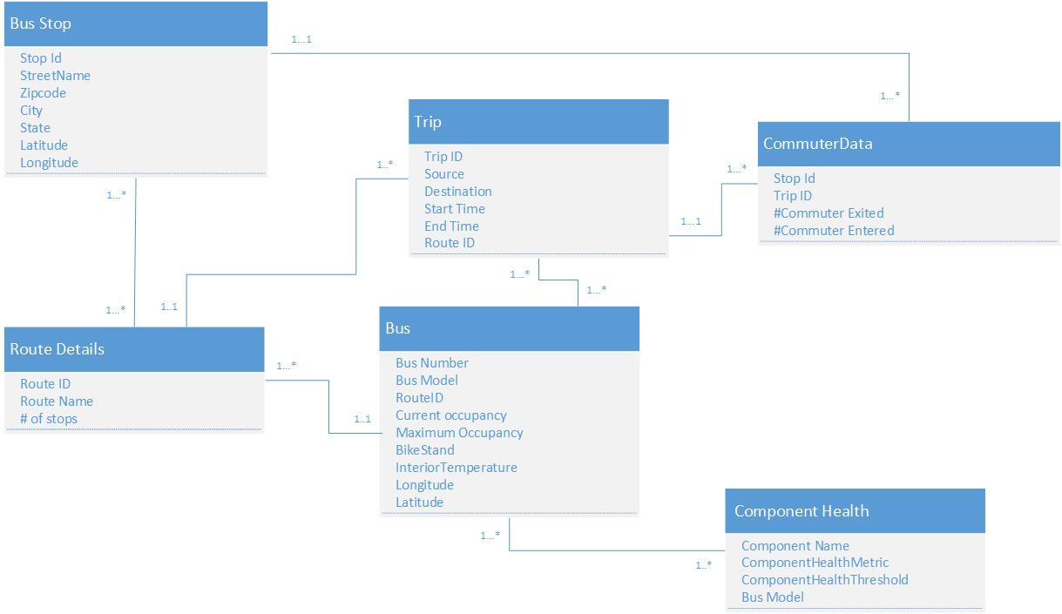

# Sequence Diagram

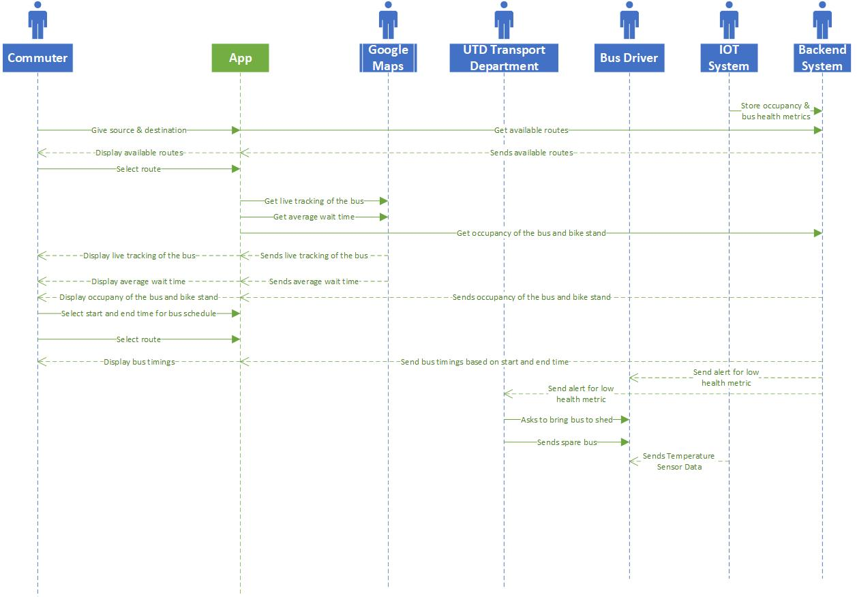

Sequence diagram for functionalities of the proposed system

# Interface Design

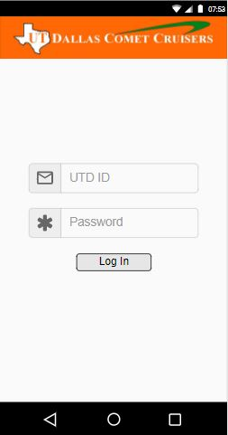

UI for Login of Comet Cruiser App

This login page is directly using existing API for login using UTD ID

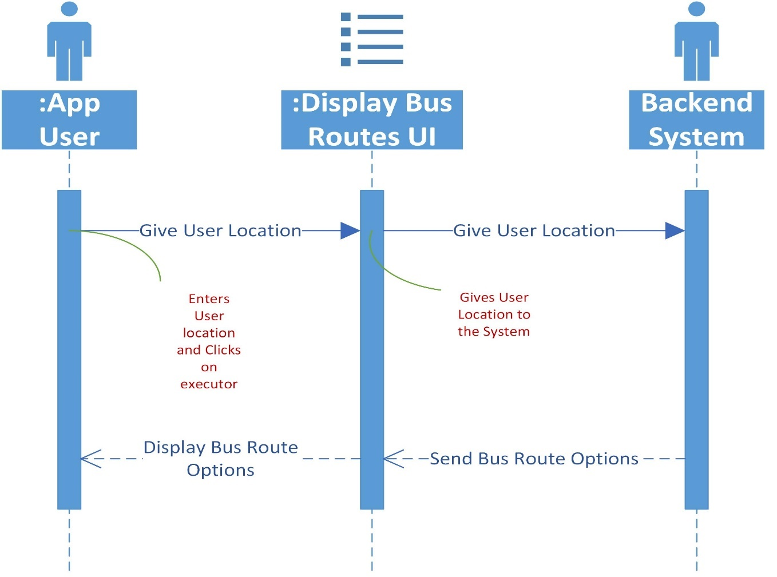

Display Bus Routes UI Sequence

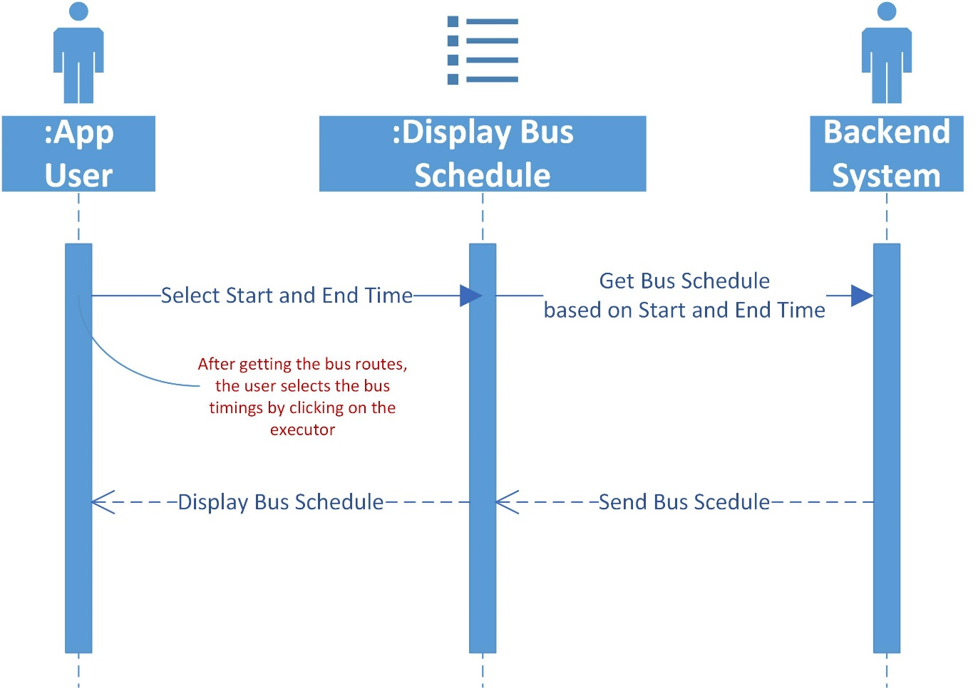

Display Bus Schedule UI Sequence

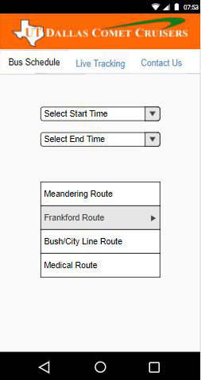 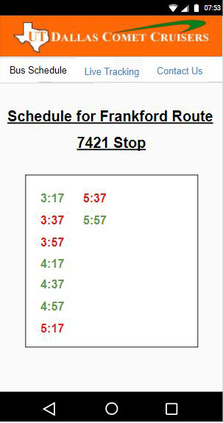

UI for Bus Schedule functionality

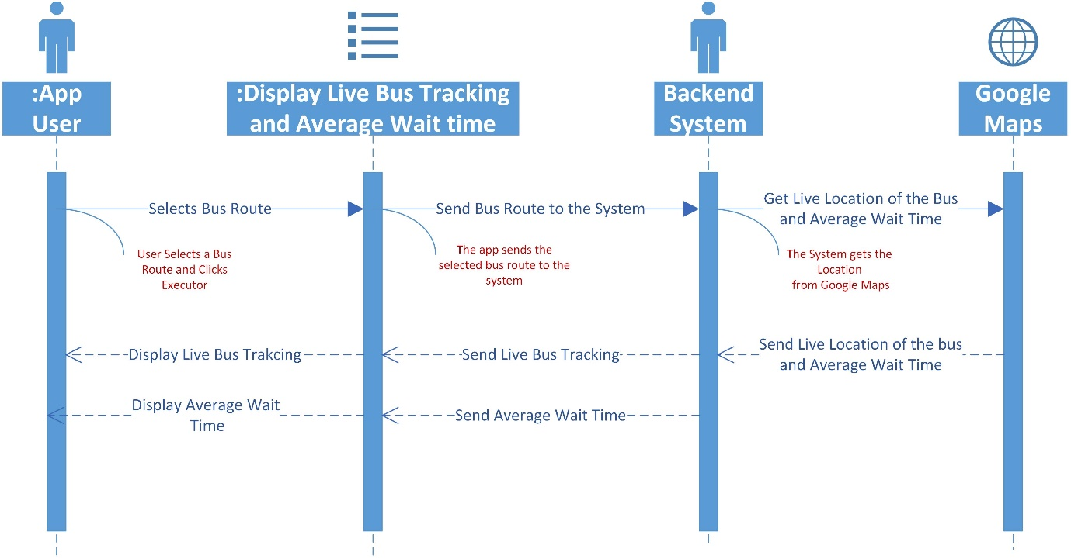

Display Live Tracking and Average Wait Time UI Sequence

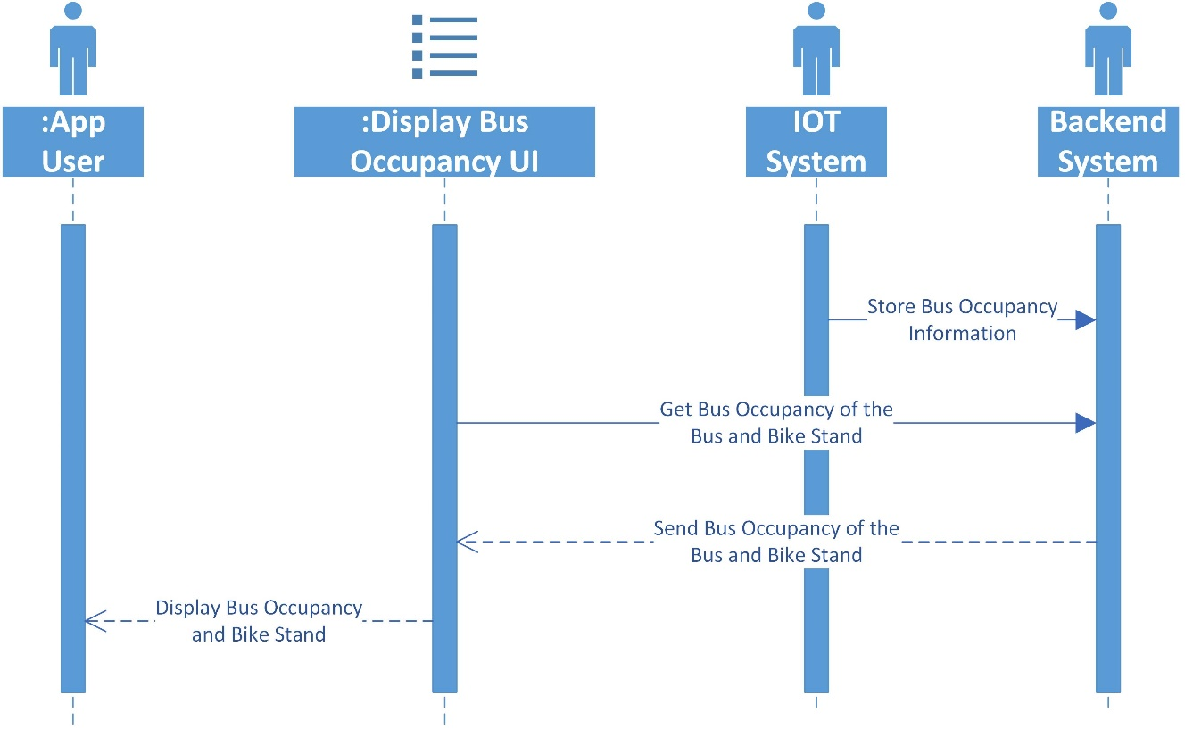

Display Bus Occupancy UI Sequence

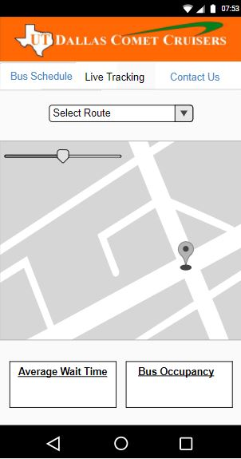

UI for Live Tracking and Bus Occupancy functionality

# Database Design

# Entity Relationship Diagram

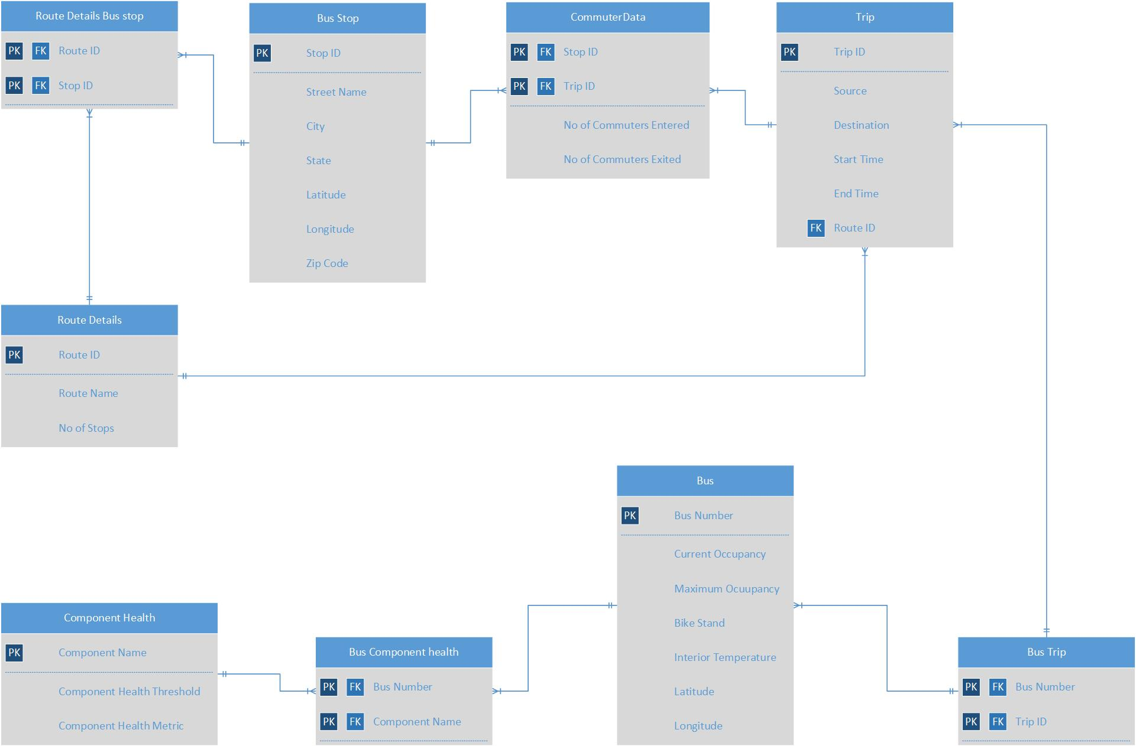

ER Diagram for the proposed system

# Design of tables

* Bus Stop (Stop ID, Street Name, Zip code, City, State, Latitude, Longitude)
* Trip (Trip ID, Source, Destination, Start Time, End Time, Route ID)
* Route Details (Route ID, Route Name, # of stops)
* Route Details Bus Stop (Route ID, Stop ID)
* Bus (Bus Number, Route ID, Current Occupancy, Maximum Occupancy, Bike stand, Interior temperature, Longitude, Latitude)
* Bus Trip (Bus Number, Trip ID)
* Component Health (Component Name, Component Health metrics, Component Health Threshold, *Stop ID, Trip ID*)
* CommuterData (Stop ID, Trip ID, # of Commuter exited, # of Commuter entered)
* Bus Component Health (Bus Number, Component Name)

# Database Constraints

* Bus Stop (Stop ID, Street Name, Zip code, City, State, Latitude, Longitude)

1. Primary key – Stop ID
2. Foreign Key – N/A
3. Unique Constraint – Stop ID
4. Not Null Constraint – Stop ID, Latitude, Longitude

* Trip (Trip ID, Source, Destination, Start Time, End Time, Route ID)

1. Primary key – Trip ID
2. Foreign Key – Route ID must exist in Table Route Details
3. Unique Constraint – Trip ID
4. Not Null Constraint- Trip ID, Route ID

* Route Details (Route ID, Route Name, # of stops)

1. Primary key – Route ID
2. Foreign Key – N/A
3. Unique Constraint – Route ID
4. Not Null Constraint - Route ID

* Route Details Bus Stop (Route ID, Stop ID)

1. Primary key – Route ID Stop ID
2. Foreign Key – N/A
3. Unique Constraint – Route ID Stop ID
4. Not Null Constraint – Route ID Stop ID

* Bus (Bus Number, Route ID, Current Occupancy, Maximum Occupancy, Bike stand, Interior temperature, Longitude, Latitude)

1. Primary key – Bus Number
2. Foreign Key – Route ID, must exist in Route Details table
3. Unique Constraint – Bus Number
4. Not Null Constraint – Bus Number, Route ID

* Bus Trip (Bus Number, Trip ID)

1. Primary key – Bus Number Trip ID
2. Foreign Key – N/A
3. Unique Constraint – Bus Number Trip ID
4. Not Null Constraint – Bus Number Trip ID

* Component Health (Component Name, Component Health metrics, Component Health Threshold)

1. Primary key – Component Name
2. Foreign Key – Stop ID, Trip ID must exist in Bus Stop table and Trip table respectively.
3. Unique Constraint – Component Name
4. Not Null Constraint – Component Name

* Bus Component Health (Bus Number, Component Name)

1. Primary key – Bus Number Component Name
2. Foreign Key – N/A
3. Unique Constraint – Bus Number Component Name
4. Not Null Constraint – Bus Number Component Name

* CommuterData (Stop ID, Trip ID, # of Commuter exited, # of Commuter entered)
  1. Primary key – Stop ID Trip ID
  2. Foreign Key – Stop ID Trip ID must exist in Bus Stop table and Trip table respectively
  3. Unique Constraint – Stop ID, Trip ID
  4. Not Null Constraint – Stop ID, Trip ID

# Class Diagram (with methods)

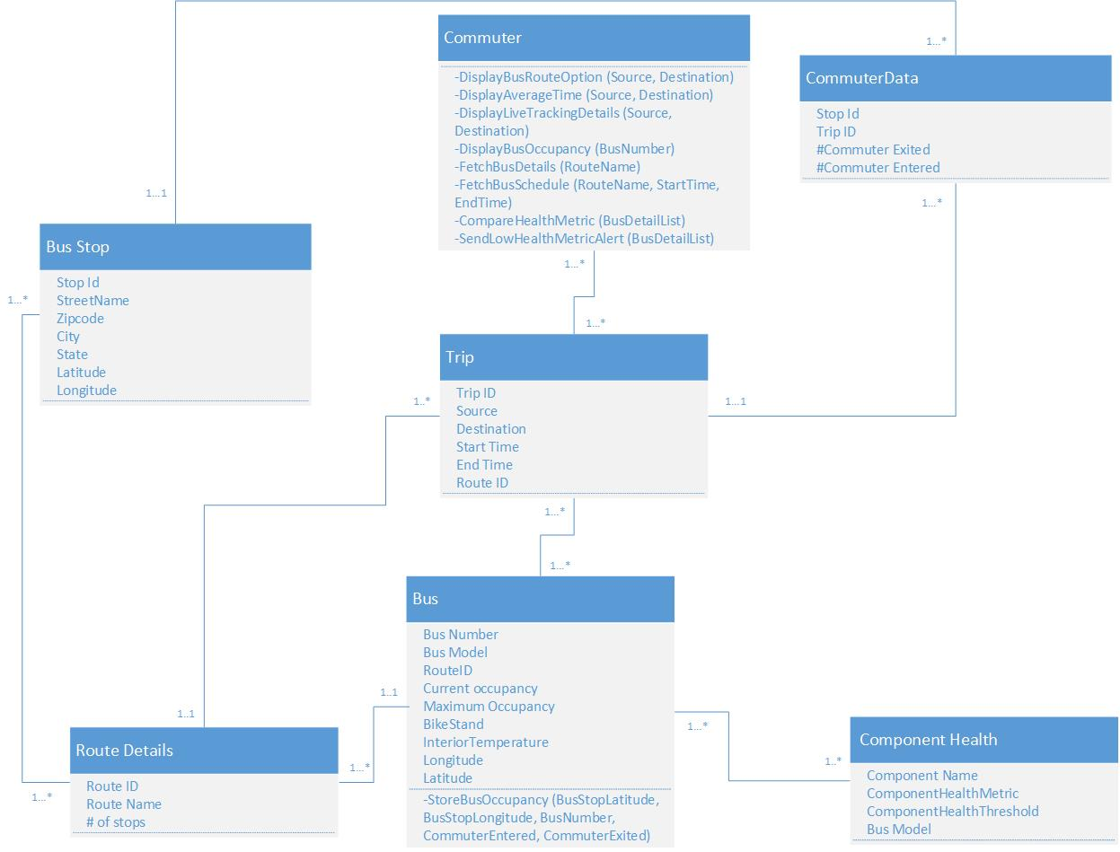

# Software Design

**Signature:**

|  |  |
| --- | --- |
| **Method name** | Display bus route options |
| **Class name** |  |
| **ID** |  |
| **Clients (Consumers)** | Commuters |
| **Associated use cases** | Track Bus and Get Average Wait Time |
| **Description of responsibilities** | Fetch the options of routes based on source and destination |
| **Arguments received** | Source and Destination for the user |
| **Type of value returned** | List of Route Names |
| **Pre-conditions** | Both source and destination value can’t be blank |
| **Post-conditions** | If no route names are available, it will return an empty list. Handling needs to be done to display “No routes available” for such scenarios.  Otherwise, display the list of route names as clickable text boxes. |

**Logic:**

* CREATE empty list
* FETCH Stop IDs for Source and Destination
* FETCH Route IDs from Route Stop Details table where Route ID has Stop IDs of source and destination both.
* IF (0 Route IDs are obtained in above step)
  + RETURN empty list
* ELSE
  + FETCH Route Name based on Route IDs obtained in above step and ADD them to the empty list
  + ADD Route Names obtained in above step to the empty list
  + RETURN list

**Signature:**

|  |  |
| --- | --- |
| **Method name** | Display average wait time |
| **Class name** |  |
| **ID** |  |
| **Clients (Consumers)** | Commuters |
| **Associated use cases** | Track Bus and Get Average Wait Time |
| **Description of responsibilities** | Fetch the average wait time based on source and destination |
| **Arguments received** | Source (Current location of bus) and Destination (Current location of user) |
| **Type of value returned** | Time in minutes |
| **Pre-conditions** | Both source and destination value can’t be blank |
| **Post-conditions** |  |

**Logic:**

* CONNECT to Google Maps API and send Source and Destination as parameters
* CONVERT JSON response into minutes format
* RETURN value obtained in above step

**Signature:**

|  |  |
| --- | --- |
| **Method name** | Display live bus tracking |
| **Class name** |  |
| **ID** |  |
| **Clients (Consumers)** | Commuters |
| **Associated use cases** | Track Bus and Get Average Wait Time |
| **Description of responsibilities** | Display the bus location on map with respect to the user’s location and route of bus to reach the user |
| **Arguments received** | Source (Current location of bus) and Destination (Current location of user) |
| **Type of value returned** | Google Map graphic format |
| **Pre-conditions** | Both source and destination value can’t be blank |
| **Post-conditions** |  |

**Logic:**

* CONNECT to Google Maps API and send Source and Destination as parameters
* CONVERT JSON response into Google Map graphic format with source displayed as bus icon and destination displayed as person icon and path connected between them as route
* RETURN value obtained in above step

**Signature:**

|  |  |
| --- | --- |
| **Method name** | Fetch bus details |
| **Class name** |  |
| **ID** |  |
| **Clients (Consumers)** | Commuters |
| **Associated use cases** | Track Bus and Get Average Wait Time |
| **Description of responsibilities** | Fetch bus details running on the route selected by the user |
| **Arguments received** | Route Name |
| **Type of value returned** | Composite value made of average time in minutes and live bus tracking as a map |
| **Pre-conditions** | Route name can’t be blank |
| **Post-conditions** | If empty value is returned, handling needs to be done to display “No buses running on selected route” for such scenarios.  Otherwise, display the average time in minutes and map of bus route. |

**Logic:**

* FETCH bus doing trip on the route selected by user
* IF (no bus is doing trip)
  + RETURN empty value
* ELSE
  + STORE average wait time in minutes by calling *“Display average wait time”* method
  + STORE bus tracking details in map format by calling *“Display live bus tracking”* method
  + CREATE composite of average wait time and bus tracking details
  + RETURN composite value

**Signature:**

|  |  |
| --- | --- |
| **Method name** | Store bus occupancy |
| **Class name** |  |
| **ID** |  |
| **Clients (Consumers)** | UTD Transport Department |
| **Associated use cases** | Get Bus Occupancy |
| **Description of responsibilities** | Based on no. of commuters entered and exited on current stop and last commuter total, store and calculate bus occupancy |
| **Arguments received** | Bus stop latitude & longitude, bus number, no. of commuters entered the bus and no. of commuters exited the bus |
| **Type of value returned** | Composite of current occupancy and maximum occupancy of the bus and current occupancy of bike stand as integers |
| **Pre-conditions** | All arguments can’t be blank |
| **Post-conditions** |  |

**Logic:**

* FETCH bus stop ID based on latitude & longitude of the bus stop
* FETCH maximum bus occupancy of the bus based on bus number
* FETCH commuter total for last stop based on bus number and bus stop ID
* FETCH no. of bikes on bike stand using bike stand sensor
* CALCULATE current occupancy of the bus by adding commuter total with no. of commuters that entered the bus and subtracting commuters that exited the bus
* STORE current occupancy

**Signature:**

|  |  |
| --- | --- |
| **Method name** | Display bus occupancy |
| **Class name** |  |
| **ID** |  |
| **Clients (Consumers)** | Commuters |
| **Associated use cases** | Get Bus Occupancy |
| **Description of responsibilities** | Based on bus number, display bus occupancy |
| **Arguments received** | Bus number |
| **Type of value returned** | Composite of current occupancy and maximum occupancy of the bus and current occupancy of bike stand as integers |
| **Pre-conditions** | Bus number can’t be blank |
| **Post-conditions** |  |

**Logic:**

* RETURN composite value of maximum occupancy and current occupancy of the bus and current occupancy of the bike stand (out of maximum of 2) based on bus number

**Signature:**

|  |  |
| --- | --- |
| **Method name** | Fetch bus schedule |
| **Class name** |  |
| **ID** |  |
| **Clients (Consumers)** | Commuters |
| **Associated use cases** | Find Bus Schedule |
| **Description of responsibilities** | Fetch bus schedule details based on the route & start and end time selected by the user |
| **Arguments received** | Route name, schedule start time and schedule end time |
| **Type of value returned** | List of bus timings |
| **Pre-conditions** | All parameters can’t be blank |
| **Post-conditions** | If empty list is returned, handling needs to be done to display “No buses running for selected schedule” for such scenarios.  Otherwise, display the various timings of the bus route. |

**Logic:**

* CREATE empty list
* FETCH bus timings based on selected start & end timings for the selected route
* IF (no bus timings are available)
  + RETURN empty list
* ELSE
  + STORE the values of bus timings returned in the above step in the list
  + RETURN list

**Signature:**

|  |  |
| --- | --- |
| **Method name** | Compare health metric |
| **Class name** |  |
| **ID** |  |
| **Clients (Consumers)** | UTD Transport System and Bus driver |
| **Associated use cases** | Receive Bus Health Alert |
| **Description of responsibilities** | Compare health metric values with their respective threshold and send low health metric alert if component has health metric value below threshold |
| **Arguments received** | List of bus number, its components, health metric values for each component and respective health metric threshold |
| **Type of value returned** | None |
| **Pre-conditions** | Data for health metric values should be present |
| **Post-conditions** | Alerts will be sent for all components for which health metric value is less than the threshold |

**Logic:**

* CREATE an empty list of objects
* ITERATE through list of input parameters
  + IF (health metric value is less than threshold)
    - Add the bus number, component name, health metric value and health metric threshold to the empty list
* If (list of objects is not empty)
  + Call *“Send low health metric alert”* method with parameter as list of objects

**Signature:**

|  |  |
| --- | --- |
| **Method name** | Send low health metric alert |
| **Class name** |  |
| **ID** |  |
| **Clients (Consumers)** | UTD Transport System and Bus driver |
| **Associated use cases** | Receive Bus Health Alert |
| **Description of responsibilities** | Send the alert when a component of the bus has low health metric |
| **Arguments received** | List of bus number, component name, health metric value for it and respective health metric threshold |
| **Type of value returned** | Text message |
| **Pre-conditions** | At least one of the components has low health metric value for one of the buses |
| **Post-conditions** | Replacement bus would be required |

**Logic:**

* ITERATE through the list of input parameters
  + CREATE message for UTD Transport Department and Bus Driver including component name, health metric value, health metric threshold
  + FETCH Bus driver details based on bus number
  + SEND message to UTD Transport Department and respective bus driver

# System Control Design

* Login used for the Comet Cruiser app is using UTD ID and Password, to ensure that this app is used only by UTD authorized commuters.
* Option to get additional bus is reserved for UTD Transportation Department and Bus Driver only.
  + UTD Transportation Department will be able to send extra bus by analysing the commuter data and understanding the peak timings.
  + Bus Driver can request for additional bus only if current bus is filled up to its maximum capacity.
* Override option is available with the driver for temperature controls, in case the temperature sensors malfunction, to prevent over-heating or over-cooling of the bus temperature.
* Average wait-time is being taken from Google Maps API. This will ensure that while calculating the ETA, it considers all the factors including traffic, weather, speed of the bus, distance to travel, etc. and returns a precise estimate.
* Three sensors are being used on each door to get precise information about number of commuters entered/exited.

# Weekly Project Timeline

|  |  |  |
| --- | --- | --- |
| **WEEKLY SCHEDULE** | | **TASKS** |
| 23rd Aug 2017 | 26th Aug 2017 | Systems Analysis and Project Management 1st session |
| 27th Aug 2017 | 2nd Sep 2017 | Group members are assigned |
| 3rd Sep 2017 | 9th Sep 2017 | Brainstorming session & merit of brainstormed ideas |
| 10th Sep 2017 | 16st Sep 2017 | Formulating ideas |
| 17th Sep 2017 | 23rd Sep 2017 | Finalizing project idea |
| 24th Sep 2017 | 30th Sep 2017 | Formulating questions for data collection |
| 1st Oct 2017 | 7th Oct 2017 | Analysis of existing system |
| 8th Oct 2017 | 14th Oct 2017 | Analysis of existing system |
| 15th Oct 2017 | 21st Oct 2017 | Discussion of functionalities in proposed system |
| 22nd Oct 2017 | 28th Oct 2017 | Analysis and discussion on scope of the project |
| 29th Oct 2017 | 4th Nov 2017 | Design of proposed system |
| 5th Nov 2017 | 11th Nov 2017 | Use Case formulation, report review, creation of use case diagrams & descriptions and data dictionary notations |
| 12th Nov 2017 | 18th Nov 2017 | Creation of data dictionary notations and sequence diagrams, review of system design and BPMN class diagrams |
| 19th Nov 2017 | 25th Nov 2017 | Creation of UI interfaces, BPMN diagrams and software design |
| 26th Nov 2017 | 2nd Dec 2017 | Report editing, system control design, creation of UI interfaces, DB design, PPT details and report deliverables |
| 3rd Dec 2017 | 9th Dec 2017 | Recording the presentation and final report review |

# Minutes of Meeting

|  |  |  |
| --- | --- | --- |
| **Meeting Number** | 1 | |
| **Meeting Date** | 3rd September 2017 | |
| **Meeting Time** | 12:00 – 14:30 | |
| **Meeting Type** | SAPM Project Group 2 Meeting | |
| **Attendees** | [Shubham Bhushanbhai](mailto:Shubham.Dave@utdallas.edu) Dave, [Chaturvedi](mailto:Chaturvedi.Musham@utdallas.edu) Musham, Tanya Bhardwaj, Sruti Seshadri | |
| **Late Attendee** | Sriram Prasath Subbiah Pandiarajan | |
| **Discussion** | Brainstorming session | |
| Discussion was carried out on different ideas for the project. Ideas included Self-help kiosk, energy converting steps, parking optimization systems, food service system, mobile goods movement system. | | |
| **Task** | | **Performed By** |
| Self-help kiosk | | [Shubham](mailto:Shubham.Dave@utdallas.edu) Dave |
| Mobile goods movement system | | [Chaturvedi](mailto:Chaturvedi.Musham@utdallas.edu) Musham |
| Food service system | | Tanya Bhardwaj |
| Energy converting steps | | Sruti Seshadri |
| Parking optimization systems | | Sriram Pandiarajan |
| **Conclusion** | Brainstormed and recorded the best ideas | |

|  |  |  |
| --- | --- | --- |
| **Meeting Number** | 2 | |
| **Meeting Date** | 5th September 2017 | |
| **Meeting Time** | 12:45 – 13:00 | |
| **Meeting Type** | SAPM Project Group 2 Meeting | |
| **Attendees** | Tanya Bhardwaj, Sruti Seshadri, Sriram Prasath Subbiah Pandiarajan | |
| **Late Attendee** |  | |
| **Discussion** | Merit of brainstormed ideas | |
| The ideas under consideration were discussed and respective pros and cons were listed. | | |
| **Task** | | **Performed By** |
| Self-help kiosk – pros and cons | | [Shubham](mailto:Shubham.Dave@utdallas.edu) Dave |
| Mobile goods movement system – pros and cons | | [Chaturvedi](mailto:Chaturvedi.Musham@utdallas.edu) Musham |
| Food service system – pros and cons | | Tanya Bhardwaj |
| Energy converting steps – pros and cons | | Sruti Seshadri |
| Parking optimization systems – pros and cons | | Sriram Pandiarajan |
| **Conclusion** | Collected more details regarding each of the ideas | |

|  |  |  |
| --- | --- | --- |
| **Meeting Number** | 3 | |
| **Meeting Date** | 16th September 2017 | |
| **Meeting Time** | 12:00 – 14:00 | |
| **Meeting Type** | SAPM Project Group 2 Meeting | |
| **Attendees** | [Shubham Bhushanbhai](mailto:Shubham.Dave@utdallas.edu) Dave, [Chaturvedi](mailto:Chaturvedi.Musham@utdallas.edu) Musham, Tanya Bhardwaj, Sruti Seshadri | |
| **Late Attendee** | Sriram Prasath Subbiah Pandiarajan | |
| **Discussion** | Formulating ideas | |
| Each member had to formulate and give a basic idea of what is to be achieved and why it helps using their idea. | | |
| **Task** | | **Performed By** |
| Self-help kiosk – draft document | | [Shubham](mailto:Shubham.Dave@utdallas.edu) Dave |
| Mobile goods system – draft document | | [Chaturvedi](mailto:Chaturvedi.Musham@utdallas.edu) Musham |
| Food service system – draft document | | Tanya Bhardwaj |
| Energy converting steps – draft document | | Sruti Seshadri |
| Parking optimization systems – draft document | | Sriram Pandiarajan |
| **Conclusion** | Created documents of ideas to present to the professor | |

|  |  |  |
| --- | --- | --- |
| **Meeting Number** | 4 | |
| **Meeting Date** | 19th September 2017 | |
| **Meeting Time** | 12:45 – 13:45 | |
| **Meeting Type** | SAPM Project Group 2 Meeting | |
| **Attendees** | [Shubham Bhushanbhai](mailto:Shubham.Dave@utdallas.edu) Dave, [Chaturvedi](mailto:Chaturvedi.Musham@utdallas.edu) Musham, Tanya Bhardwaj, Sruti Seshadri, Sriram Prasath Subbiah Pandiarajan | |
| **Late Attendee** |  | |
| **Discussion** | Finalizing project idea | |
| Defined the scope of each of our ideas and presented the ideas to the professor. Finalized on one of the ideas of improving Comet Cruiser system. | | |
| **Task** | | **Performed By** |
| Self-help kiosk – scope and presentation | | [Shubham](mailto:Shubham.Dave@utdallas.edu) Dave |
| Mobile goods system– scope and presentation | | [Chaturvedi](mailto:Chaturvedi.Musham@utdallas.edu) Musham |
| Food service system – scope and presentation | | Tanya Bhardwaj |
| Energy converting steps – scope and presentation | | Sruti Seshadri |
| Parking systems – scope and presentation | | Sriram Pandiarajan |
| **Conclusion** | Finalized on the optimization of the Comet Cruiser system | |

|  |  |  |
| --- | --- | --- |
| **Meeting Number** | 5 | |
| **Meeting Date** | 30th September 2017 | |
| **Meeting Time** | Online | |
| **Meeting Type** | SAPM Project Group 2 Meeting | |
| **Attendees** | [Shubham Bhushanbhai](mailto:Shubham.Dave@utdallas.edu) Dave, [Chaturvedi](mailto:Chaturvedi.Musham@utdallas.edu) Musham, Tanya Bhardwaj, Sruti Seshadri, Sriram Prasath Subbiah Pandiarajan | |
| **Late Attendee** |  | |
| **Discussion** | Accumulated questions for data collection | |
| Discussed about what is required to understand the existing system and came up with the questions which we need to ask in the public information request to analyse the existing system. | | |
| **Task** | | **Performed By** |
| Existing system – data collection | | [Shubham](mailto:Shubham.Dave@utdallas.edu) Dave |
| Existing system – data collection | | [Chaturvedi](mailto:Chaturvedi.Musham@utdallas.edu) Musham |
| Existing system – data collection | | Tanya Bhardwaj |
| Existing system – data collection | | Sruti Seshadri |
| Existing system – data collection | | Sriram Pandiarajan |
| **Conclusion** | Finalized the questions to be included for Public Information Request | |

|  |  |
| --- | --- |
| **Meeting Number** | 6 |
| **Meeting Date** | 11th October 2017 |
| **Meeting Time** | Online |
| **Meeting Type** | SAPM Project Group 2 Meeting |
| **Attendees** | [Shubham Bhushanbhai](mailto:Shubham.Dave@utdallas.edu) Dave, [Chaturvedi](mailto:Chaturvedi.Musham@utdallas.edu) Musham, Tanya Bhardwaj, Sruti Seshadri Sriram Prasath Subbiah Pandiarajan |
| **Late Attendee** |  |
| **Discussion** | Analysis of existing system |
| Document and discussed the merit of the existing system using images. | |
| **Conclusion** | Documented about incorporation of functionalities and optimization of existing system |

|  |  |  |
| --- | --- | --- |
| **Meeting Number** | 7 | |
| **Meeting Date** | 24th October 2017 | |
| **Meeting Time** | 12:40 – 13:15 | |
| **Meeting Type** | SAPM Project Group 2 Meeting | |
| **Attendees** | [Shubham Bhushanbhai](mailto:Shubham.Dave@utdallas.edu) Dave, Tanya Bhardwaj, Sruti Seshadri | |
| **Late Attendee** |  | |
| **Discussion** | Discussion of functionalities | |
| Discussed about adding IOT to bus stops and bus doors.  Discussed about new routes that might help commuters in resolving current problems. | | |
| **Task** | | **Performed By** |
| Proposed solution – IOT inside vehicle | | [Shubham](mailto:Shubham.Dave@utdallas.edu) Dave |
| - | | [Chaturvedi](mailto:Chaturvedi.Musham@utdallas.edu) Musham |
| Proposed solution – Step sensors | | Tanya Bhardwaj |
| Proposed solution – New route designs | | Sruti Seshadri |
| - | | Sriram Pandiarajan |
| **Conclusion** | Functions and additional features of proposed system were noted | |

|  |  |  |
| --- | --- | --- |
| **Meeting Number** | 8 | |
| **Meeting Date** | 28th October 2017 | |
| **Meeting Time** | Online | |
| **Meeting Type** | SAPM Project Group 2 Meeting | |
| **Attendees** | [Shubham Bhushanbhai](mailto:Shubham.Dave@utdallas.edu) Dave, [Chaturvedi](mailto:Chaturvedi.Musham@utdallas.edu) Musham, Tanya Bhardwaj, Sruti Seshadri | |
| **Late Attendee** | Sriram Prasath Subbiah Pandiarajan | |
| **Discussion** | Analysis and scope of the project | |
| Finalized the scope of the project and the design of each component that was proposed. | | |
| **Task** | | **Performed By** |
| Proposed solution – scope and parameters | | [Shubham](mailto:Shubham.Dave@utdallas.edu) Dave |
| Proposed solution – scope and parameters | | [Chaturvedi](mailto:Chaturvedi.Musham@utdallas.edu) Musham |
| Proposed solution – scope and parameters | | Tanya Bhardwaj |
| Proposed solution – scope and parameters | | Sruti Seshadri |
| Proposed solution – scope and parameters | | Sriram Pandiarajan |
| **Conclusion** | Created first draft of project deliverables | |

|  |  |  |
| --- | --- | --- |
| **Meeting Number** | 9 | |
| **Meeting Date** | 31st October 2017 | |
| **Meeting Time** | 13:00 – 14:30 | |
| **Meeting Type** | SAPM Project Group 2 Meeting | |
| **Attendees** | [Shubham Bhushanbhai](mailto:Shubham.Dave@utdallas.edu) Dave, [Chaturvedi](mailto:Chaturvedi.Musham@utdallas.edu) Musham, Tanya Bhardwaj, Sruti Seshadri | |
| **Late Attendee** | Sriram Prasath Subbiah Pandiarajan | |
| **Discussion** | Design of proposed system | |
| Features and incorporation of features for the proposed system | | |
| **Task** | | **Performed By** |
| Context diagram – draft & first draft of full report | | [Shubham](mailto:Shubham.Dave@utdallas.edu) Dave |
| Use Case diagram – draft | | [Chaturvedi](mailto:Chaturvedi.Musham@utdallas.edu) Musham |
| Relative merits of features | | Tanya Bhardwaj |
| Vehicle IOT features | | Sruti Seshadri |
| Scope of system features | | Sriram Pandiarajan |
| **Conclusion** | First draft of context diagram and project report | |

|  |  |  |
| --- | --- | --- |
| **Meeting Number** | 10 | |
| **Meeting Date** | 5th November 2017 | |
| **Meeting Time** | 14:00 – 16:00 | |
| **Meeting Type** | SAPM Project Group 2 Meeting | |
| **Attendees** | [Shubham Bhushanbhai](mailto:Shubham.Dave@utdallas.edu) Dave, [Chaturvedi](mailto:Chaturvedi.Musham@utdallas.edu) Musham, Tanya Bhardwaj | |
| **Late Attendee** | Sriram Prasath Subbiah Pandiarajan | |
| **Discussion** | Use Case formulation and report review | |
| Designed the use case diagrams and created first draft of report. | | |
| **Task** | | **Performed By** |
| Use Case Diagram 1 – design | | [Shubham](mailto:Shubham.Dave@utdallas.edu) Dave |
| Use Case Diagram 2 – design | | [Chaturvedi](mailto:Chaturvedi.Musham@utdallas.edu) Musham |
| Use Case Diagram 3 – design | | Tanya Bhardwaj |
| - | | Sruti Seshadri |
| Scope of system features | | Sriram Pandiarajan |
| **Conclusion** | Created first draft of Use Cases | |
| **Meeting Number** | 11 | |
| **Meeting Date** | 7th November 2017 | |
| **Meeting Time** | 13:00 – 16:00 | |
| **Meeting Type** | SAPM Project Group 2 Meeting | |
| **Attendees** | [Shubham Bhushanbhai](mailto:Shubham.Dave@utdallas.edu) Dave, [Chaturvedi](mailto:Chaturvedi.Musham@utdallas.edu) Musham, Tanya Bhardwaj, Sruti Seshadri | |
| **Late Attendee** |  | |
| **Discussion** | Vehicle health data and Use case diagram and descriptions | |
| Researched vehicle health IOT and started the design of use case descriptions | | |
| **Task** | | **Performed By** |
| Use case description 1 | | [Shubham](mailto:Shubham.Dave@utdallas.edu) Dave |
| Use case description 2 | | [Chaturvedi](mailto:Chaturvedi.Musham@utdallas.edu) Musham |
| Use case description 3 | | Tanya Bhardwaj |
| Vehicle Health IOT implementation | | Sruti Seshadri |
| - | | Sriram Pandiarajan |
| **Conclusion** | Created Visio diagrams of use cases | |

|  |  |
| --- | --- |
| **Meeting Number** | 12 |
| **Meeting Date** | 9th November 2017 |
| **Meeting Time** | Online |
| **Meeting Type** | SAPM Project Group 2 Meeting |
| **Attendees** | [Shubham Bhushanbhai](mailto:Shubham.Dave@utdallas.edu) Dave, [Chaturvedi](mailto:Chaturvedi.Musham@utdallas.edu) Musham, Tanya Bhardwaj, Sruti Seshadri |
| **Late Attendee** |  |
| **Discussion** | Formulated questions for 2nd public information request |
| Formulated the questions to be submitted for public information request | |
| **Conclusion** | Recorded the questions and data required from the public information request |

|  |  |  |
| --- | --- | --- |
| **Meeting Number** | 13 | |
| **Meeting Date** | 11th November 2017 | |
| **Meeting Time** | 10:30 – 12:30 | |
| **Meeting Type** | SAPM Project Group 2 Meeting | |
| **Attendees** | [Shubham Bhushanbhai](mailto:Shubham.Dave@utdallas.edu) Dave, [Chaturvedi](mailto:Chaturvedi.Musham@utdallas.edu) Musham, Tanya Bhardwaj, Sruti Seshadri | |
| **Late Attendee** |  | |
| **Discussion** | Created use case description and data dictionary notations | |
| Completed use case descriptions and started data dictionary notations | | |
| **Task** | | **Performed By** |
| Data dictionary notations | | [Shubham](mailto:Shubham.Dave@utdallas.edu) Dave |
| Use case description review | | [Chaturvedi](mailto:Chaturvedi.Musham@utdallas.edu) Musham |
| Data dictionary notations | | Tanya Bhardwaj |
| Use case description and diagram review | | Sruti Seshadri |
| - | | Sriram Pandiarajan |
| **Conclusion** | Completed use case descriptions | |

|  |  |  |
| --- | --- | --- |
| **Meeting Number** | 14 | |
| **Meeting Date** | 13th November 2017 | |
| **Meeting Time** | 13:00 – 17:00 | |
| **Meeting Type** | SAPM Project Group 2 Meeting | |
| **Attendees** | [Shubham Bhushanbhai](mailto:Shubham.Dave@utdallas.edu) Dave, [Chaturvedi](mailto:Chaturvedi.Musham@utdallas.edu) Musham, Tanya Bhardwaj, Sruti Seshadri | |
| **Late Attendee** |  | |
| **Discussion** | Created data dictionary notations and sequence diagrams | |
| Completed data dictionary notations and started sequence diagrams | | |
| **Task** | | **Performed By** |
| Data dictionary notations | | [Shubham](mailto:Shubham.Dave@utdallas.edu) Dave |
| Sequence diagrams | | [Chaturvedi](mailto:Chaturvedi.Musham@utdallas.edu) Musham |
| Data dictionary notations | | Tanya Bhardwaj |
| Sequence diagrams | | Sruti Seshadri |
| - | | Sriram Pandiarajan |
| **Conclusion** | Completed data dictionary notation and started design of sequence diagrams | |

|  |  |  |
| --- | --- | --- |
| **Meeting Number** | 15 | |
| **Meeting Date** | 18th November 2017 | |
| **Meeting Time** | 10:00 – 12:00 | |
| **Meeting Type** | SAPM Project Group 2 Meeting | |
| **Attendees** | [Shubham Bhushanbhai](mailto:Shubham.Dave@utdallas.edu) Dave, [Chaturvedi](mailto:Chaturvedi.Musham@utdallas.edu) Musham, Tanya Bhardwaj, Sruti Seshadri | |
| **Late Attendee** |  | |
| **Discussion** | Review of system control design, BPMN diagrams and revision of sequence diagrams | |
| Divided work after discussion of deliverables.  Reviewed system control design and BPMN diagrams | | |
| **Task** | | **Performed By** |
| Review of system control design | | [Shubham](mailto:Shubham.Dave@utdallas.edu) Dave |
| Sequence diagram review | | [Chaturvedi](mailto:Chaturvedi.Musham@utdallas.edu) Musham |
| Class diagram – with methods | | Tanya Bhardwaj |
| BPMN diagrams | | Sruti Seshadri |
| - | | Sriram Pandiarajan |
| **Conclusion** | Updated the report with all deliverables completed till date. | |

|  |  |  |
| --- | --- | --- |
| **Meeting Number** | 16 | |
| **Meeting Date** | 26th November 2017 | |
| **Meeting Time** | 18:00 – 22:00 | |
| **Meeting Type** | SAPM Project Group 2 Meeting | |
| **Attendees** | [Shubham Bhushanbhai](mailto:Shubham.Dave@utdallas.edu) Dave, [Chaturvedi](mailto:Chaturvedi.Musham@utdallas.edu) Musham, Tanya Bhardwaj, Sruti Seshadri | |
| **Late Attendee** |  | |
| **Discussion** | UI interfaces, BPMN design, software design and UI interfaces | |
| Review and changes on each member’s completed designs | | |
| **Task** | | **Performed By** |
| Software design | | [Shubham](mailto:Shubham.Dave@utdallas.edu) Dave |
| UI Interface design | | [Chaturvedi](mailto:Chaturvedi.Musham@utdallas.edu) Musham |
| Class diagram – without methods | | Tanya Bhardwaj |
| BPMN diagram | | Sruti Seshadri |
| - | | Sriram Pandiarajan |
| **Conclusion** | Completed UI interfaces, BPMN diagrams, class diagrams and software design | |

|  |  |  |
| --- | --- | --- |
| **Meeting Number** | 17 | |
| **Meeting Date** | 28th November 2017 | |
| **Meeting Time** | 13:00 – 15:00 | |
| **Meeting Type** | SAPM Project Group 2 Meeting | |
| **Attendees** | [Shubham Bhushanbhai](mailto:Shubham.Dave@utdallas.edu) Dave, [Chaturvedi](mailto:Chaturvedi.Musham@utdallas.edu) Musham, Tanya Bhardwaj, Sruti Seshadri, Sriram Prasath Subbiah Pandiarajan | |
| **Late Attendee** |  | |
| **Discussion** | Report editing, system control design, UI interfaces, Database design | |
| Review and final format documentation of each member’s work | | |
| **Task** | | **Performed By** |
| System control design & report editing, documentation – references, proposed solution, functional specifications | | [Shubham](mailto:Shubham.Dave@utdallas.edu) Dave |
| UI interface design | | [Chaturvedi](mailto:Chaturvedi.Musham@utdallas.edu) Musham |
| DB design and ER diagram | | Tanya Bhardwaj |
| MoM & weekly project timeline | | Sruti Seshadri |
|  | | Sriram Pandiarajan |
| **Conclusion** | Completed system control design, UI interfaces and DB design. | |

|  |  |
| --- | --- |
| **Meeting Number** | 18 |
| **Meeting Date** | 1st December 2017 |
| **Meeting Time** | Online – conference call |
| **Meeting Type** | SAPM Project Group 2 Meeting |
| **Attendees** | [Shubham Bhushanbhai](mailto:Shubham.Dave@utdallas.edu) Dave, [Chaturvedi](mailto:Chaturvedi.Musham@utdallas.edu) Musham, Tanya Bhardwaj, Sruti Seshadri |
| **Late Attendee** |  |
| **Discussion** | PPT details and report deliverables |
| Details of PPT deliverables | |
| **Conclusion** | Time and place of PPT and voice over meeting |

|  |  |  |
| --- | --- | --- |
| **Meeting Number** | 19 | |
| **Meeting Date** | 6th December 2017 | |
| **Meeting Time** | 20:00 – 22:00 | |
| **Meeting Type** | SAPM Project Group 2 Meeting | |
| **Attendees** | [Shubham Bhushanbhai](mailto:Shubham.Dave@utdallas.edu) Dave, [Chaturvedi](mailto:Chaturvedi.Musham@utdallas.edu) Musham, Tanya Bhardwaj, Sruti Seshadri, Sriram Prasath Subbiah Pandiarajan | |
| **Late Attendee** |  | |
| **Discussion** | Recording of final presentation and final report review | |
|  | | |
| **Task** | | **Performed By** |
| Project report – review | | [Shubham](mailto:Shubham.Dave@utdallas.edu) Dave |
| PPT – review | | [Chaturvedi](mailto:Chaturvedi.Musham@utdallas.edu) Musham |
| PPT – completion | | Tanya Bhardwaj |
| PPT – first draft | | Sruti Seshadri |
|  | | Sriram Pandiarajan |
| **Conclusion** | Project PPT and voice recordings completed | |

# References

* “*Object-Oriented Systems Analysis and Design*” by Jeff Hoffer, Joey George, and Joe Valacich, Pearson Prentice-Hall, Second Edition, 2006
* Data obtained from UTD Transportation Department through public information request.
* *“Who owns the road? The IOT-connected car of today—and tomorrow”* –[https://dupress.deloitte.com/dup-us-en/focus/internet-of-things/IOT-in-automotive-industry.html](https://dupress.deloitte.com/dup-us-en/focus/internet-of-things/iot-in-automotive-industry.html)
* *“Telecoms versus carmakers in race to get connected”* –<https://www.ft.com/content/6c1b7f60-a9d3-11e7-93c5-648314d2c72c?segmentid=acee4131-99c2-09d3-a635-873e61754ec6>
* *“List of temperature sensors”* – <https://en.wikipedia.org/wiki/List_of_temperature_sensors>
* *“How sensor technology will shape the cars of the future”* – <https://www.melexis.com/en/insights/knowhow/how-sensor-technology-shape-cars-future>
* *“EGR Flap Position Sensing in Powertrain (Automotive)”* – <https://www.melexis.com/en/applications/egr-flap-position-sensing>
* “*People Counters, Retail Traffic Counting & Pedestrian Door Counters - Traf-Sys*” – <https://www.trafsys.com/people-counting/>